Torus
# Source: AI Source: Provided by: [Data Path: Persons Table -> ID Column: 1, Name_En Column: Motasem Essam] -> From: [ChatGPT] on [7/25/2026]
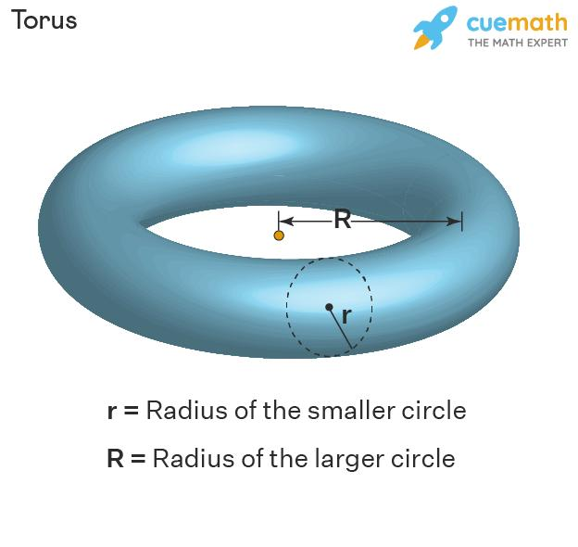
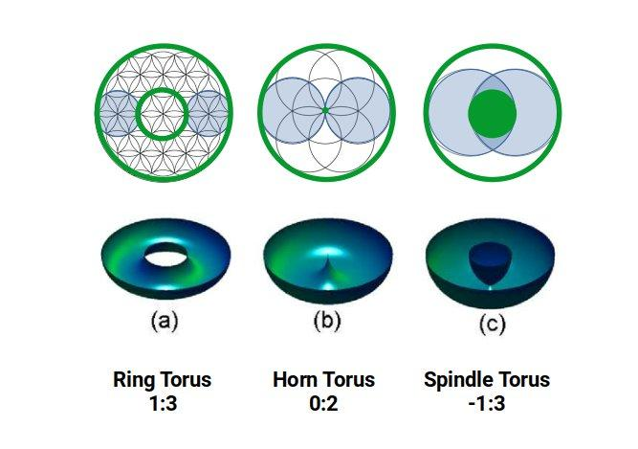

Definition
# Source: AI Source: Provided by: [Data Path: Persons Table -> ID Column: 1, Name_En Column: Motasem Essam] -> From: [ChatGPT] on [7/25/2026]
A torus is a three-dimensional solid formed by revolving a circle around a coplanar axis that does not pass through the circle's interior. In the standard ring-shaped case, the circle revolves around an external axis, producing a doughnut-shaped solid with a central hole.
The torus has a curved outer surface and a curved inner surface. Unlike a sphere or ellipsoid, a ring torus has a hole passing through its middle.

Simple Definition
# Source: AI Source: Provided by: [Data Path: Persons Table -> ID Column: 1, Name_En Column: Motasem Essam] -> From: [ChatGPT] on [7/25/2026]
A torus is a doughnut-shaped solid formed by rotating a circle around an axis outside that circle.

Key Characteristics
# Source: AI Source: Provided by: [Data Path: Persons Table -> ID Column: 1, Name_En Column: Motasem Essam] -> From: [ChatGPT] on [7/25/2026]
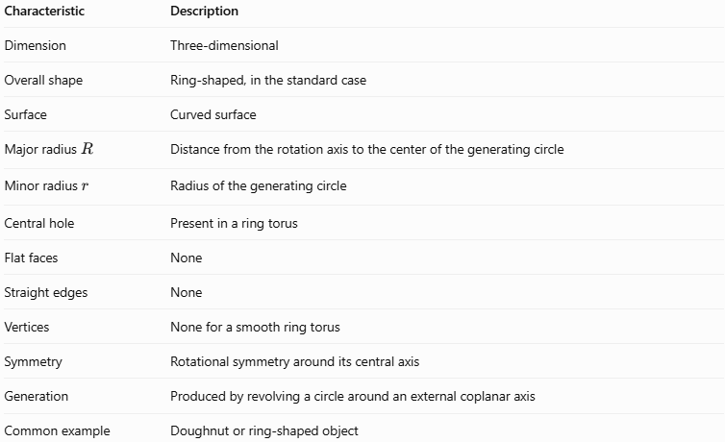
Characteristic | Description
Dimension | Three-dimensional
Overall shape | Ring-shaped, in the standard case
Surface | Curved surface
Major radius $R$ | Distance from the rotation axis to the center of the generating circle
Minor radius $r$ | Radius of the generating circle
Central hole | Present in a ring torus
Flat faces | None
Straight edges | None
Vertices | None for a smooth ring torus
Symmetry | Rotational symmetry around its central axis
Generation | Produced by revolving a circle around an external coplanar axis
Common example | Doughnut or ring-shaped object

Geometric Representation
# Source: AI Source: Provided by: [Data Path: Persons Table -> ID Column: 1, Name_En Column: Motasem Essam] -> From: [ChatGPT] on [7/25/2026]
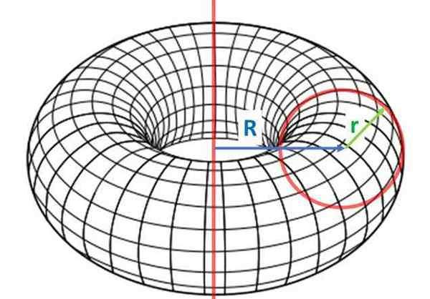
A torus is described using two radii:
- Major radius ($R$): the distance from the central axis of rotation to the center of the circular tube.
- Minor radius ($r$): the radius of the circular tube itself.
For a ring torus, the outer radius from the central axis is $R+r$, while the inner radius of the hole is $R-r$.
Therefore:
$$\text{Outer radius}=R+r$$
$$\text{Inner radius}=R-r$$

Types by shape

Ring torus
# Source: AI Source: Provided by: [Data Path: Persons Table -> ID Column: 1, Name_En Column: Motasem Essam] -> From: [ChatGPT] on [7/25/2026]
The generating circle does not touch the rotation axis, leaving a hole.
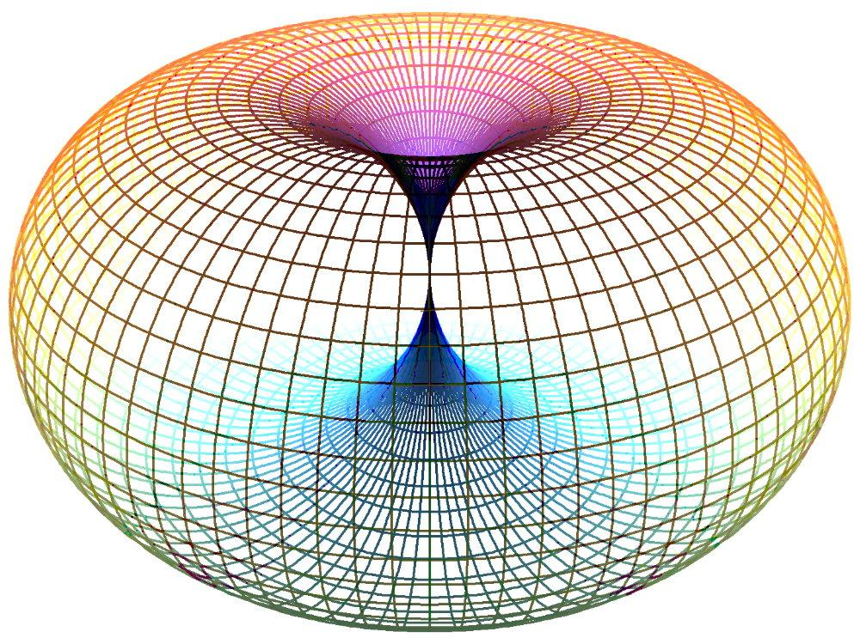

Horn torus
# Source: AI Source: Provided by: [Data Path: Persons Table -> ID Column: 1, Name_En Column: Motasem Essam] -> From: [ChatGPT] on [7/25/2026]
The generating circle touches the rotation axis at one point, closing the hole to a point.
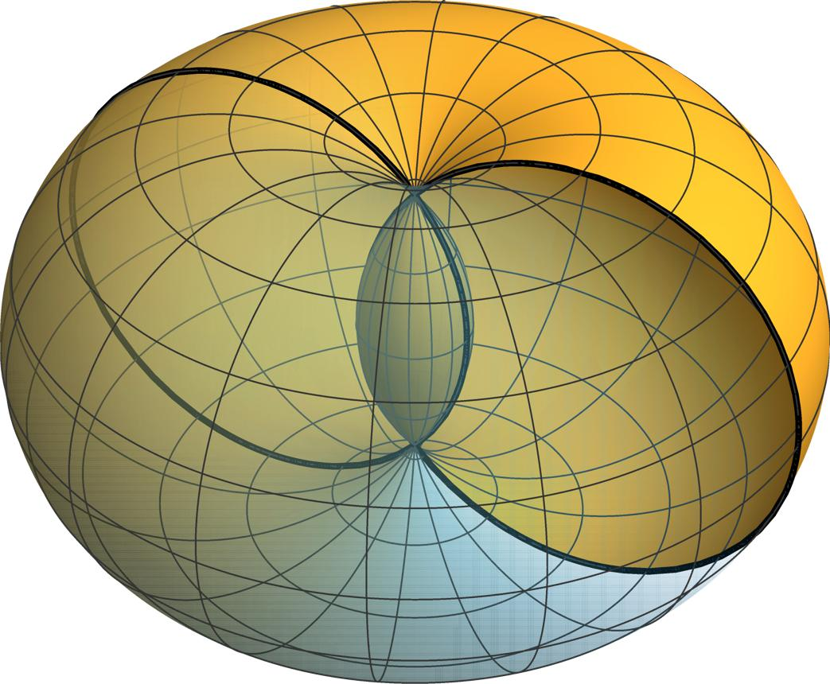

Spindle torus
# Source: AI Source: Provided by: [Data Path: Persons Table -> ID Column: 1, Name_En Column: Motasem Essam] -> From: [ChatGPT] on [7/25/2026]
the generating circle crosses the rotation axis, creating a pinched, self-intersecting surface in the usual mathematical construction. It differs from the ordinary doughnut-shaped ring torus.

Mathematical Representations and Formulas

Standard Equation
# Source: AI Source: Provided by: [Data Path: Persons Table -> ID Column: 1, Name_En Column: Motasem Essam] -> From: [ChatGPT] on [7/25/2026]
For a torus centered around the $z$-axis, with major radius $R$ and minor radius $r$, the standard surface equation is:
$${\left(\sqrt{x^{2}+y^{2}}-R\right)}^{2}+z^{2}=r^{2}$$
An equivalent polynomial form is:
$${\left(x^{2}+y^{2}+z^{2}+R^{2}-r^{2}\right)}^{2}=4R^{2}\left(x^{2}+y^{2}\right)$$
These equations describe the torus surface. For a ring torus, the solid itself consists of points satisfying:
$${\left(\sqrt{x^{2}+y^{2}}-R\right)}^{2}+z^{2}≤r^{2}$$

Main Formulas for a Ring Torus
# Source: AI Source: Provided by: [Data Path: Persons Table -> ID Column: 1, Name_En Column: Motasem Essam] -> From: [ChatGPT] on [7/25/2026]
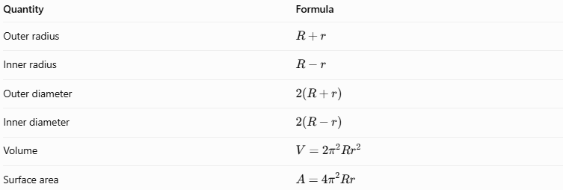
Quantity | Formula
Outer radius | $$R+r$$
Inner radius | $$R-r$$
Outer diameter | $$2\left(R+r\right)$$
Inner diameter | $$2\left(R-r\right)$$
Volume | $$V=2π^{2}Rr^{2}$$
Surface area | $$A=4π^{2}Rr$$
These volume and surface-area formulas apply to the standard ring torus, where $R>r$.

Understanding the Formulas
# Source: AI Source: Provided by: [Data Path: Persons Table -> ID Column: 1, Name_En Column: Motasem Essam] -> From: [ChatGPT] on [7/25/2026]
The volume can be derived using the circle's area and the distance traveled by its center during rotation:
$$V=\left(πr^{2}\right)\left(2πR\right)$$
Therefore,
$$\boxed{V=2π^{2}Rr^{2}}$$
The surface area follows from rotating the circumference of the generating circle around the central axis:
$$A=\left(2πr\right)\left(2πR\right)$$
Therefore,
$$\boxed{A=4π^{2}Rr}$$

Worked Examples
# Source: AI Source: Provided by: [Data Path: Persons Table -> ID Column: 1, Name_En Column: Motasem Essam] -> From: [ChatGPT] on [7/25/2026]
Example 1: Calculate the Volume
A ring torus has major radius $R=5\text{ cm}$ and minor radius $r=2\text{ cm}$. Find its volume.
Solution
$$V=2π^{2}Rr^{2}$$
Substitute the values:
$$V=2π^{2}\left(5\right)\left(2^{2}\right)$$
$$V=40π^{2}$$
$$\boxed{V≈394.78{\text{ cm}}^{3}}$$
Example 2: Calculate the Surface Area
A torus has major radius $R=6\text{ cm}$ and minor radius $r=3\text{ cm}$. Find its surface area.
Solution
$$A=4π^{2}Rr$$
$$A=4π^{2}\left(6\right)\left(3\right)$$
$$A=72π^{2}$$
$$\boxed{A≈710.61{\text{ cm}}^{2}}$$
Example 3: Find the Inner and Outer Radii
A ring torus has $R=8\text{ cm}$ and $r=3\text{ cm}$.
The outer radius is:
$$R+r=8+3=\boxed{11\text{ cm}}$$
The inner radius is:
$$R-r=8-3=\boxed{5\text{ cm}}$$
The central hole therefore has a diameter of $10\text{ cm}$.
Example 4: Identify the Type of Torus
Classify each shape using its major and minor radii.

Major radius $R$ | Minor radius $r$ | Classification
7 cm | 3 cm | Ring torus, because $R>r$
4 cm | 4 cm | Horn torus, because $R=r$
2 cm | 5 cm | Spindle torus, because $R<r$

Constructing a Torus

Geometric Instruments
# Source: AI Source: Provided by: [Data Path: Persons Table -> ID Column: 1, Name_En Column: Motasem Essam] -> From: [ChatGPT] on [7/25/2026]
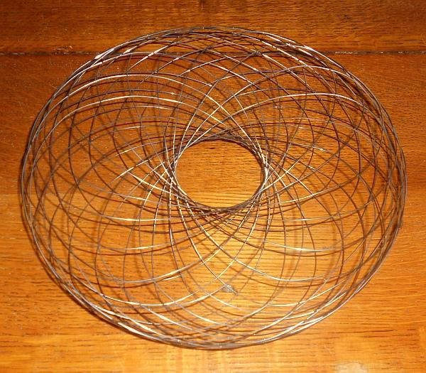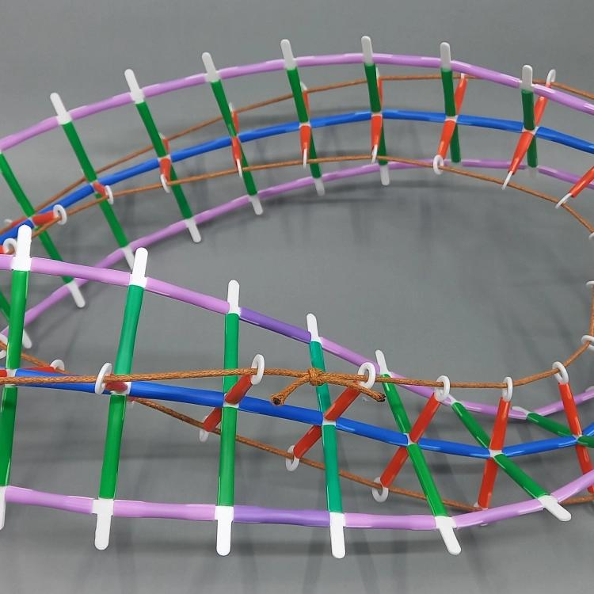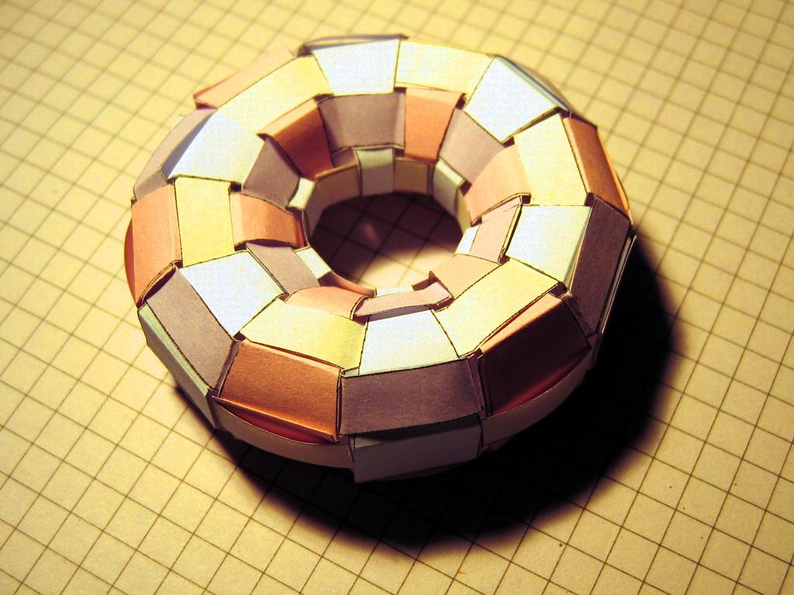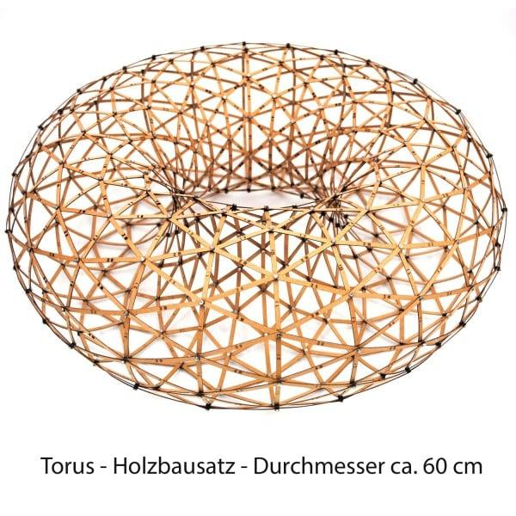
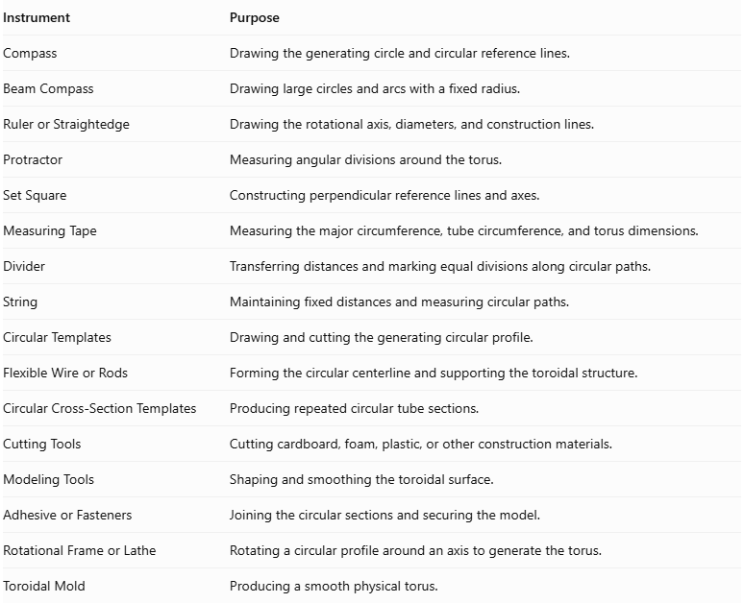
Instrument | Purpose
Compass | Drawing the generating circle and circular reference lines.
Beam Compass | Drawing large circles and arcs with a fixed radius.
Ruler or Straightedge | Drawing the rotational axis, diameters, and construction lines.
Protractor | Measuring angular divisions around the torus.
Set Square | Constructing perpendicular reference lines and axes.
Measuring Tape | Measuring the major circumference, tube circumference, and torus dimensions.
Divider | Transferring distances and marking equal divisions along circular paths.
String | Maintaining fixed distances and measuring circular paths.
Circular Templates | Drawing and cutting the generating circular profile.
Flexible Wire or Rods | Forming the circular centerline and supporting the toroidal structure.
Circular Cross-Section Templates | Producing repeated circular tube sections.
Cutting Tools | Cutting cardboard, foam, plastic, or other construction materials.
Modeling Tools | Shaping and smoothing the toroidal surface.
Adhesive or Fasteners | Joining the circular sections and securing the model.
Rotational Frame or Lathe | Rotating a circular profile around an axis to generate the torus.
Toroidal Mold | Producing a smooth physical torus.

Instrument-Based Construction Procedures

Method 1: Constructing a Ring Torus Using Rotational Symmetry
# Source: AI Source: Provided by: [Data Path: Persons Table -> ID Column: 1, Name_En Column: Motasem Essam] -> From: [ChatGPT] on [7/25/2026]
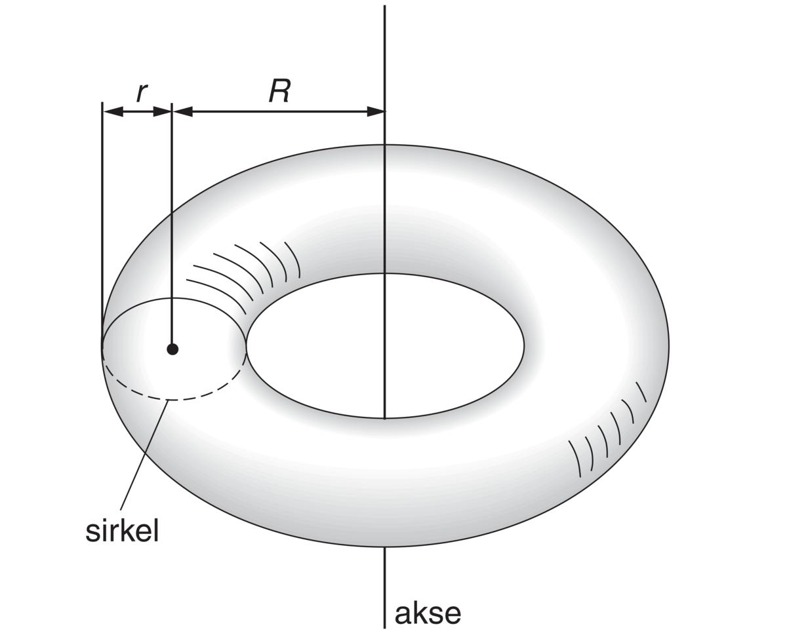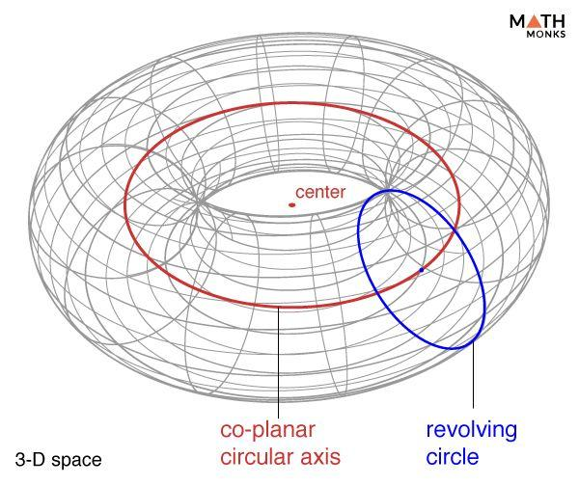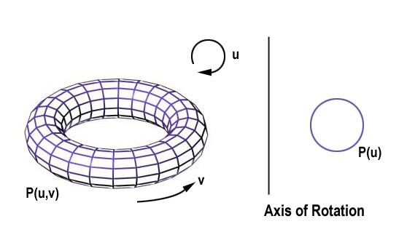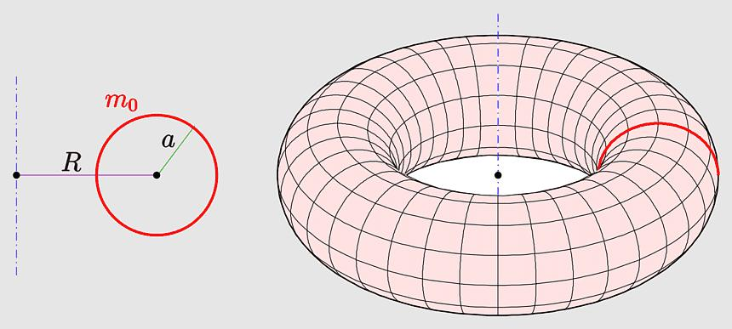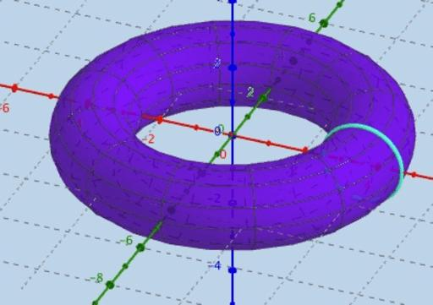
- Determine the required major radius $R$ and minor radius $r$.
- Ensure that $R>r$ to construct a ring torus.
- Draw a horizontal reference line representing the rotational axis.
- Mark a point at perpendicular distance $R$ from the rotational axis.
- Use a compass to draw a circle of radius $r$ centered at this point.
- Ensure that the generating circle does not intersect the rotational axis.
- Prepare a circular profile from cardboard, plastic, or another suitable material.
- Position the generating circle in a rotational frame with the reference axis as its axis of rotation.
- Rotate the circular profile through a complete ${360}^{°}$ revolution.
- Observe the resulting ring-shaped surface.
- Use the rotating profile as a guide to shape a physical torus.
- Smooth the surface and verify the major and minor radii.
Geometric principle: A circle revolved around a coplanar external axis that does not intersect it generates a ring torus.

Method 2: Constructing a Torus Using Circular Cross-Sections
# Source: AI Source: Provided by: [Data Path: Persons Table -> ID Column: 1, Name_En Column: Motasem Essam] -> From: [ChatGPT] on [7/25/2026]
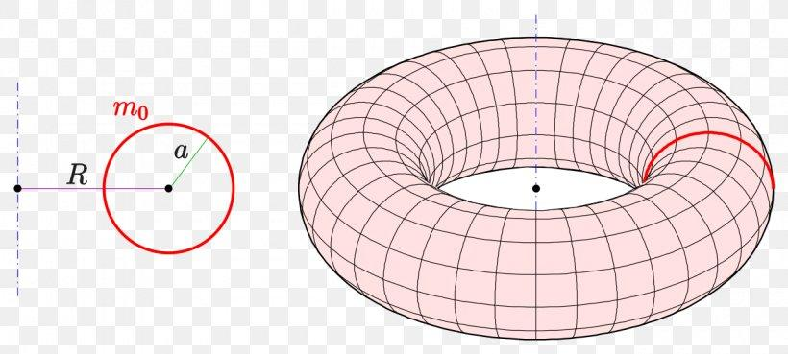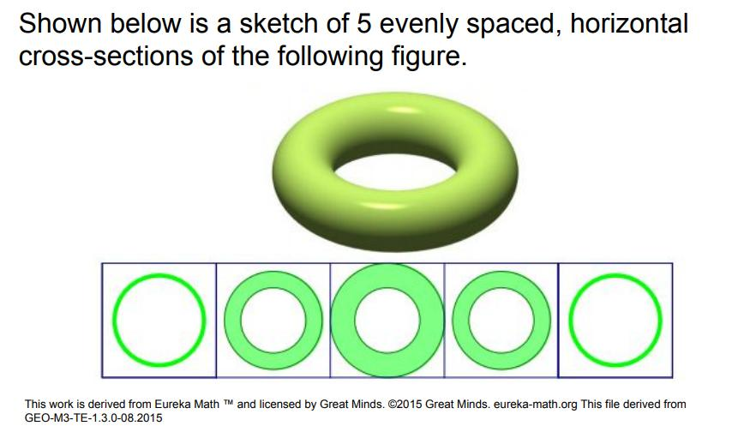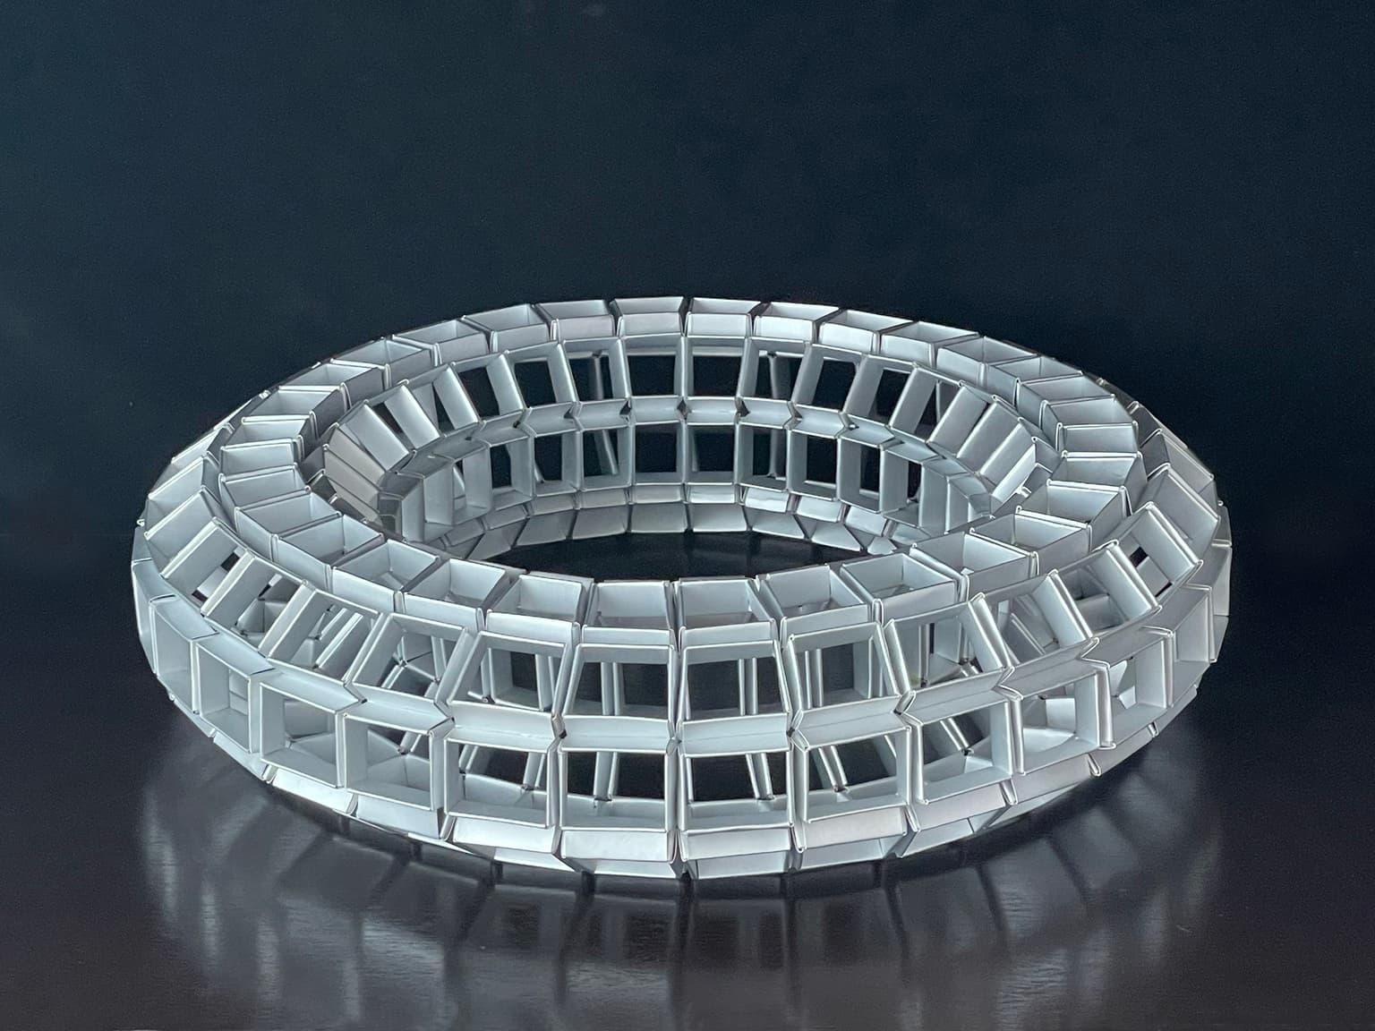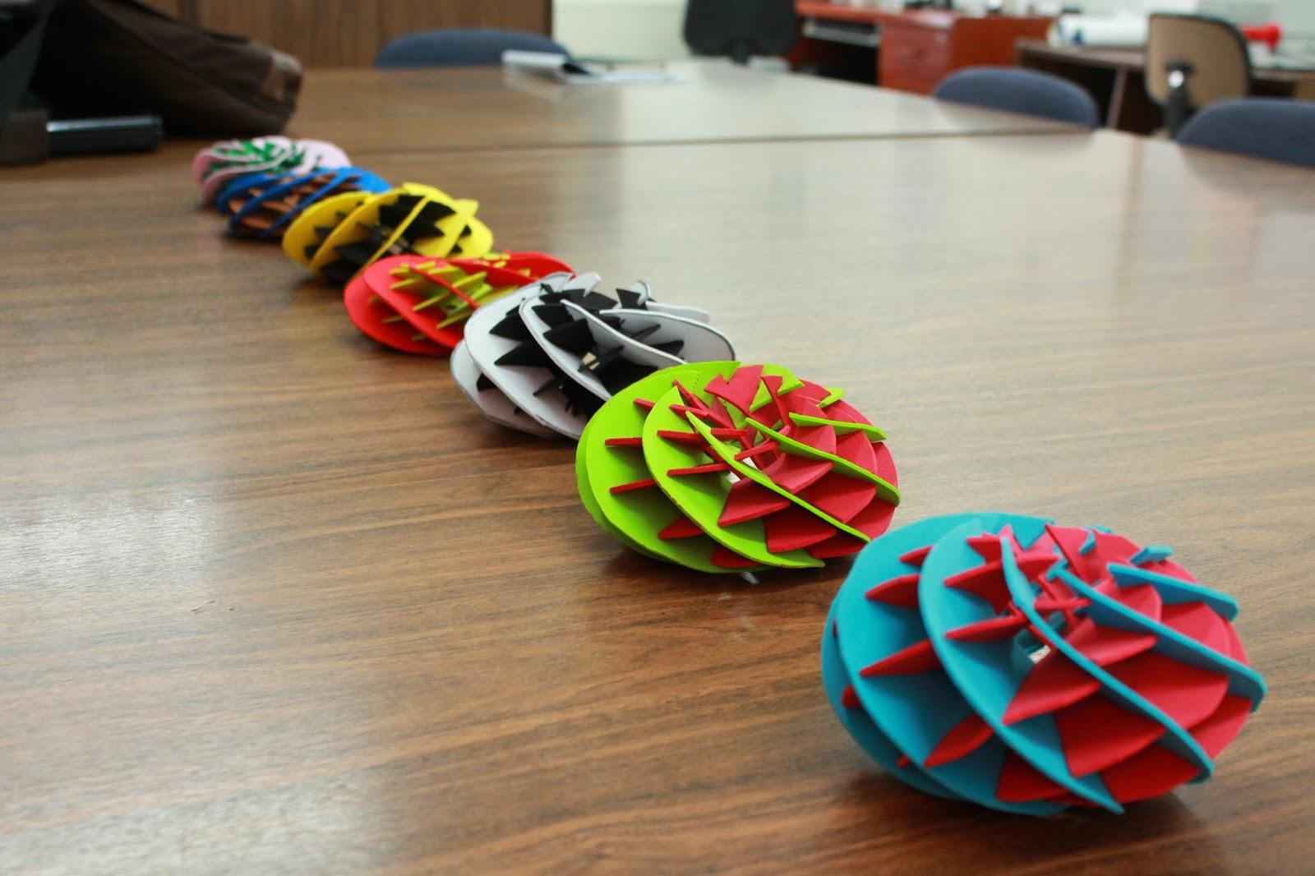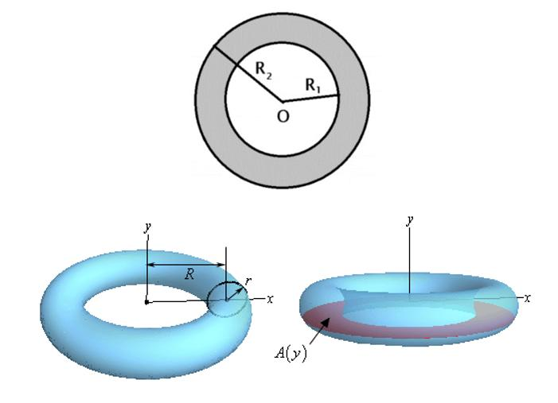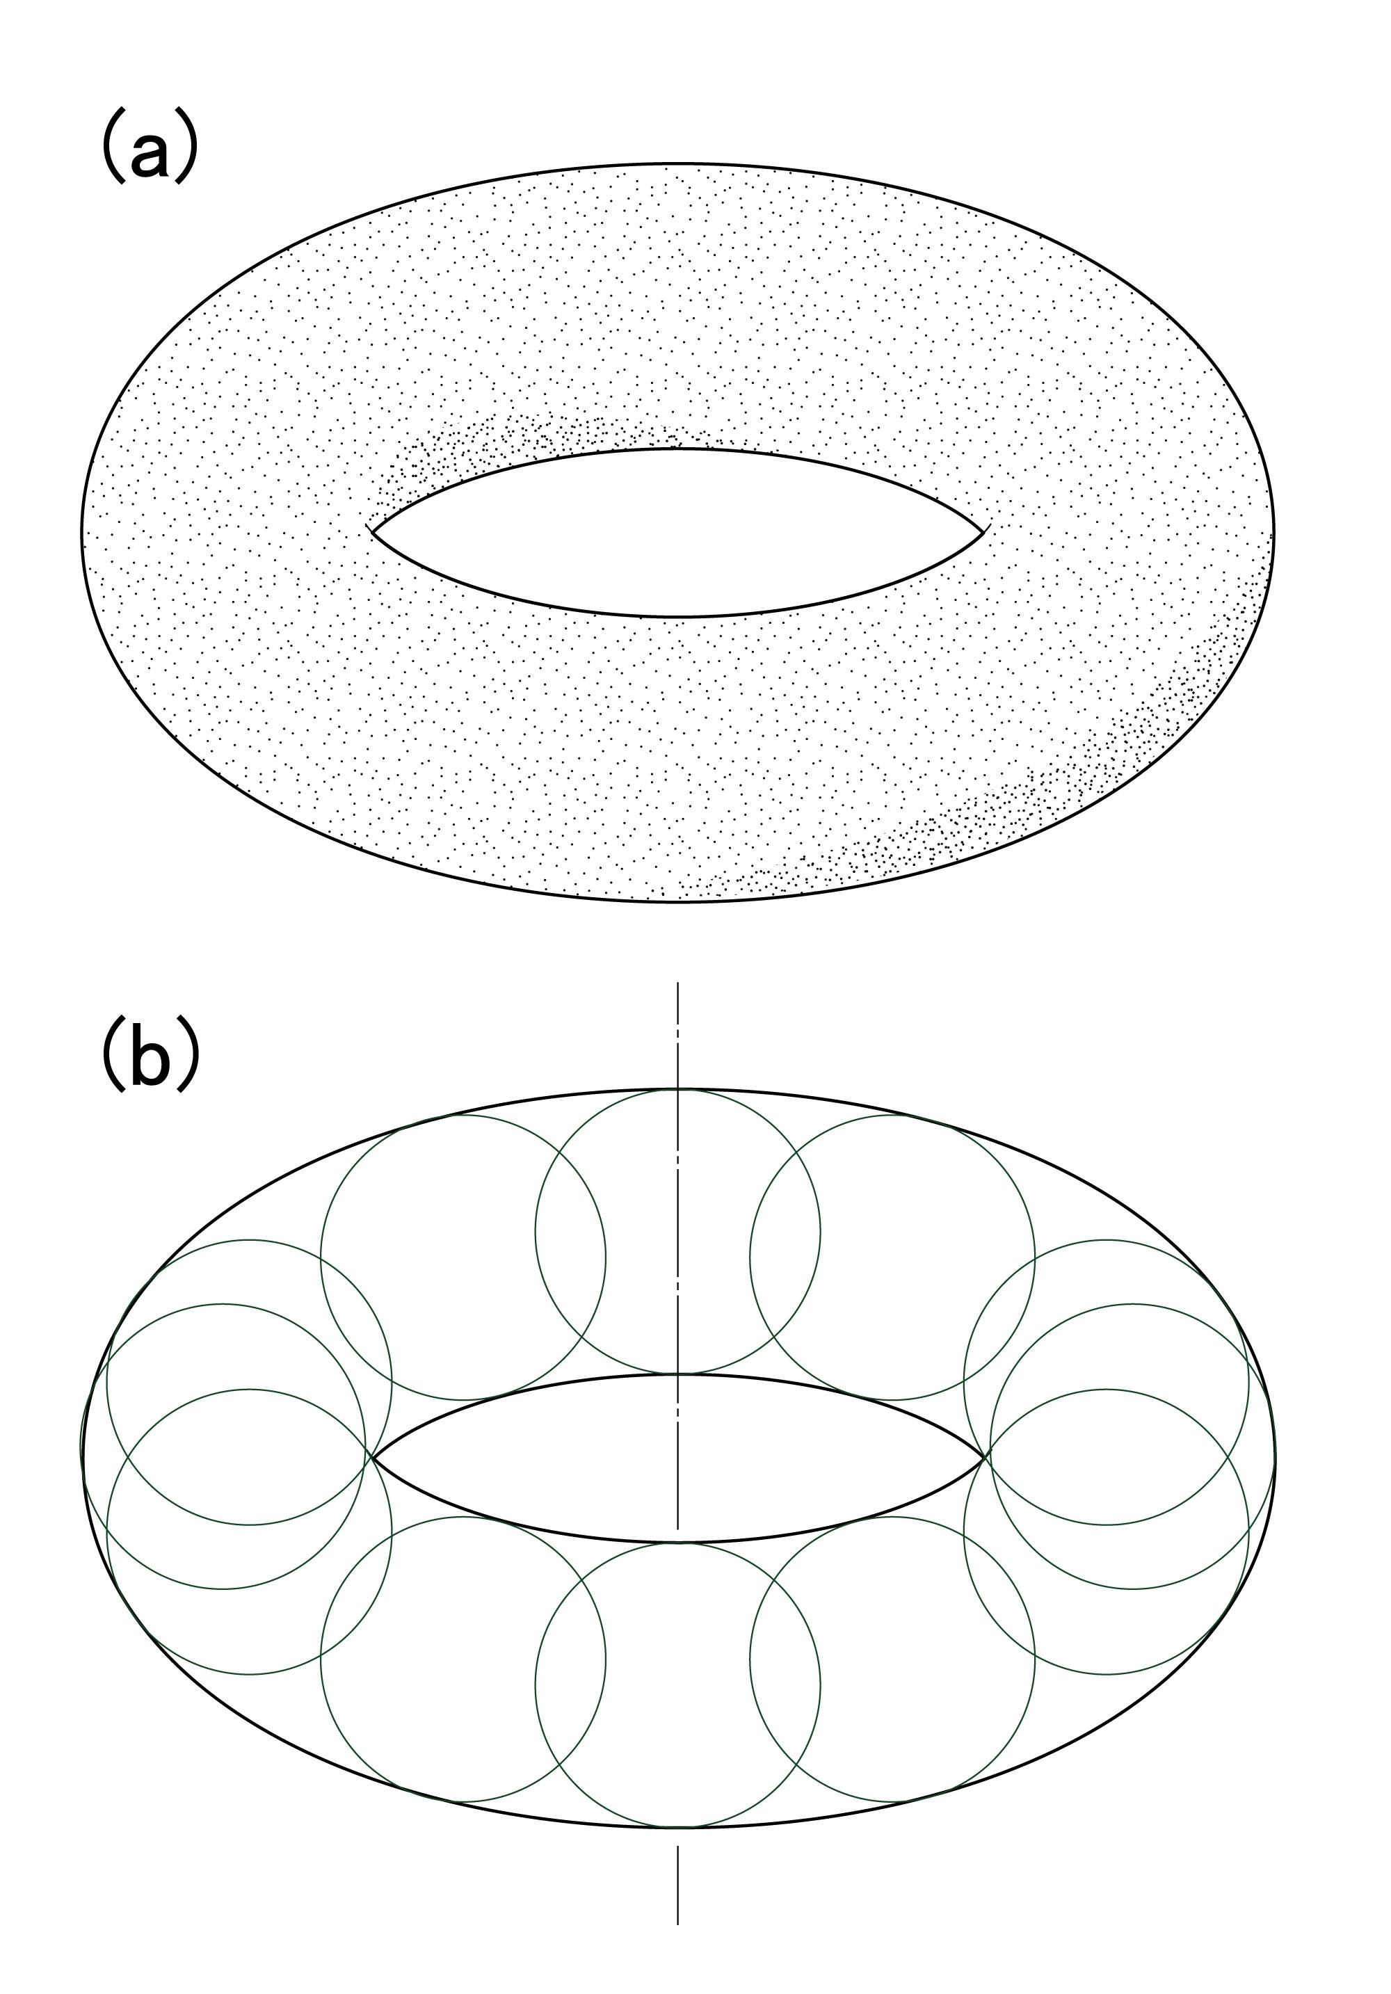
- Determine the required major radius $R$ and minor radius $r$.
- Draw a large reference circle with radius $R$, representing the circular path of the tube's center.
- Divide the reference circle into several equal angular sections using a protractor.
- Mark the center of each circular section along the reference circle.
- Draw a small circle of radius $r$ at each marked center, in a plane perpendicular to the circular path.
- Cut the circular sections from foam, cardboard, or another suitable material.
- Arrange the sections around the circular path.
- Align adjacent sections so their centers follow the same circular path.
- Join the sections using adhesive or suitable fasteners.
- Fill the gaps between sections with modeling material.
- Smooth the outer and inner surfaces to create a continuous toroidal shape.
- Verify the central opening and the tube's uniform thickness.

Method 3: Constructing a Torus Using a Circular Tube Bent into a Ring
# Source: AI Source: Provided by: [Data Path: Persons Table -> ID Column: 1, Name_En Column: Motasem Essam] -> From: [ChatGPT] on [7/25/2026]
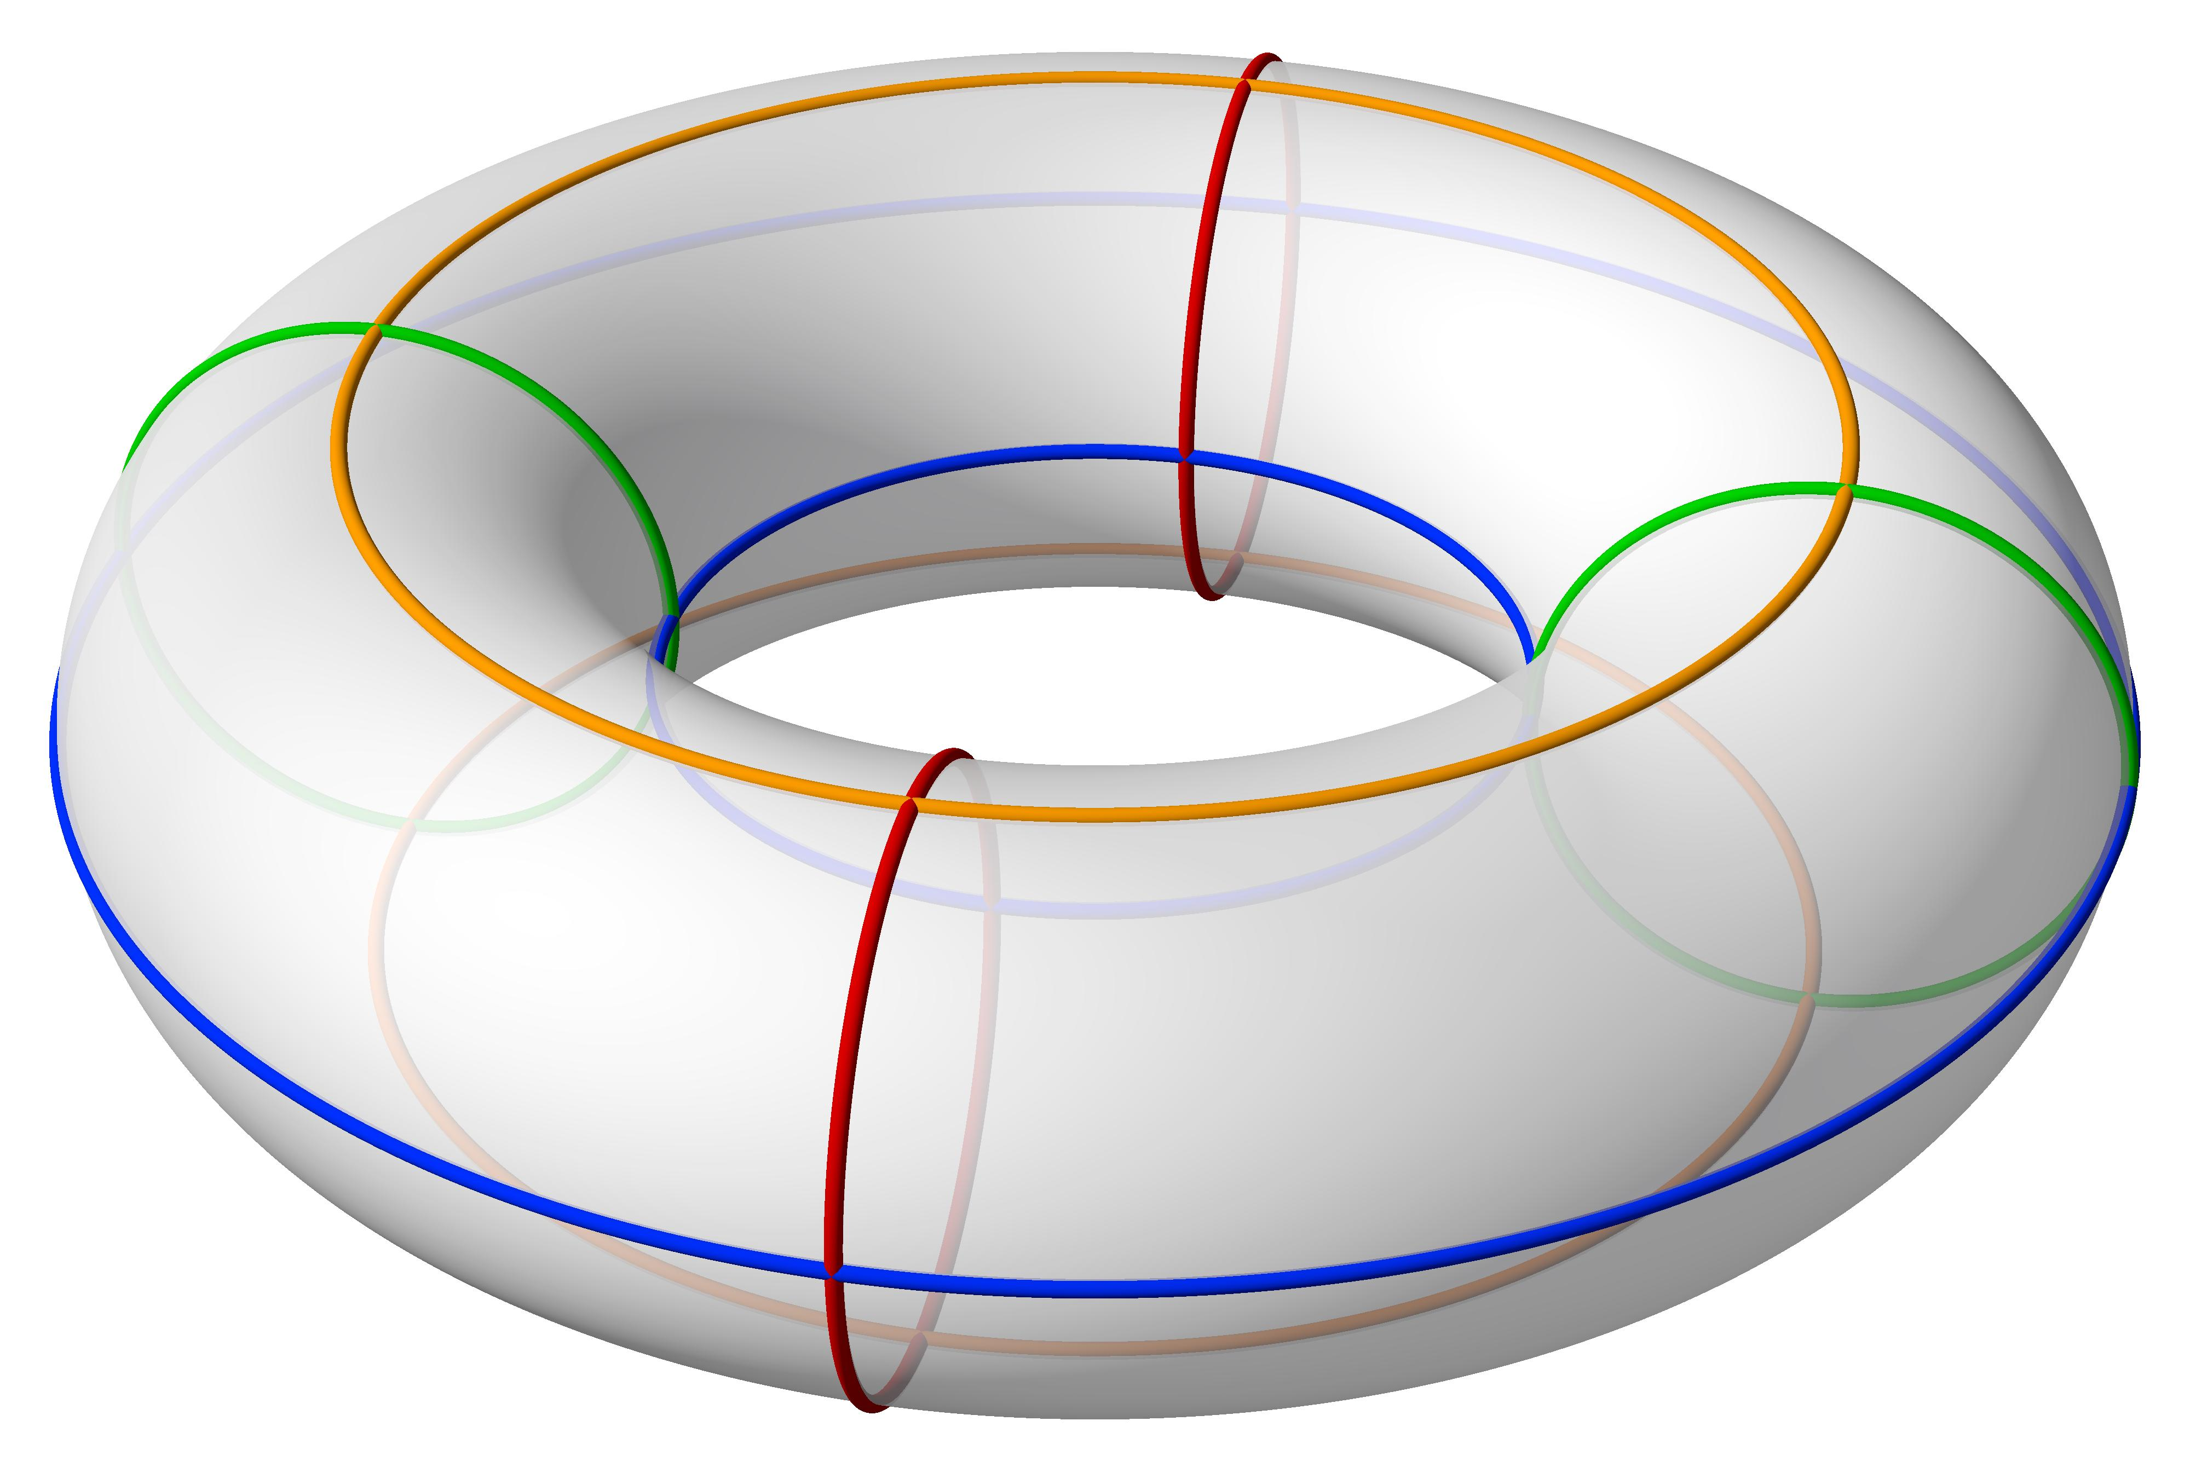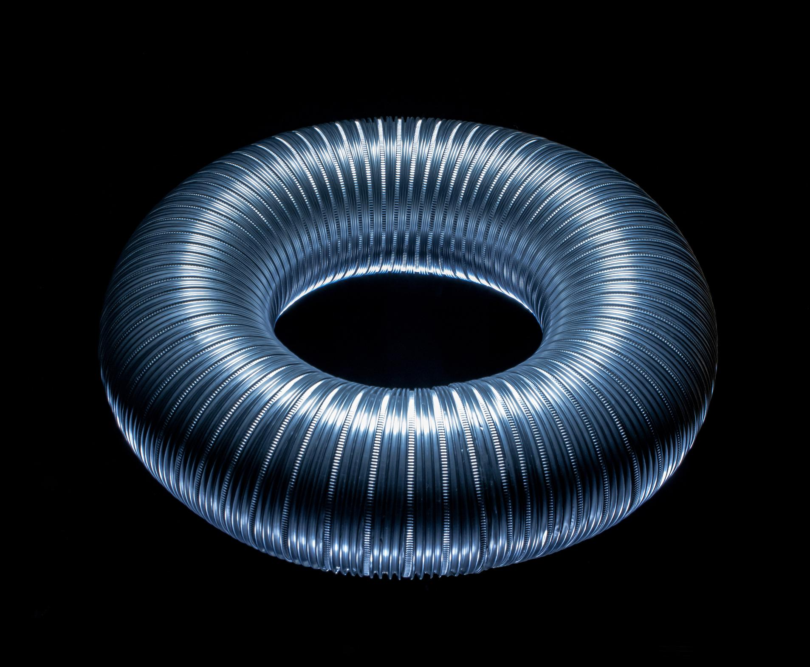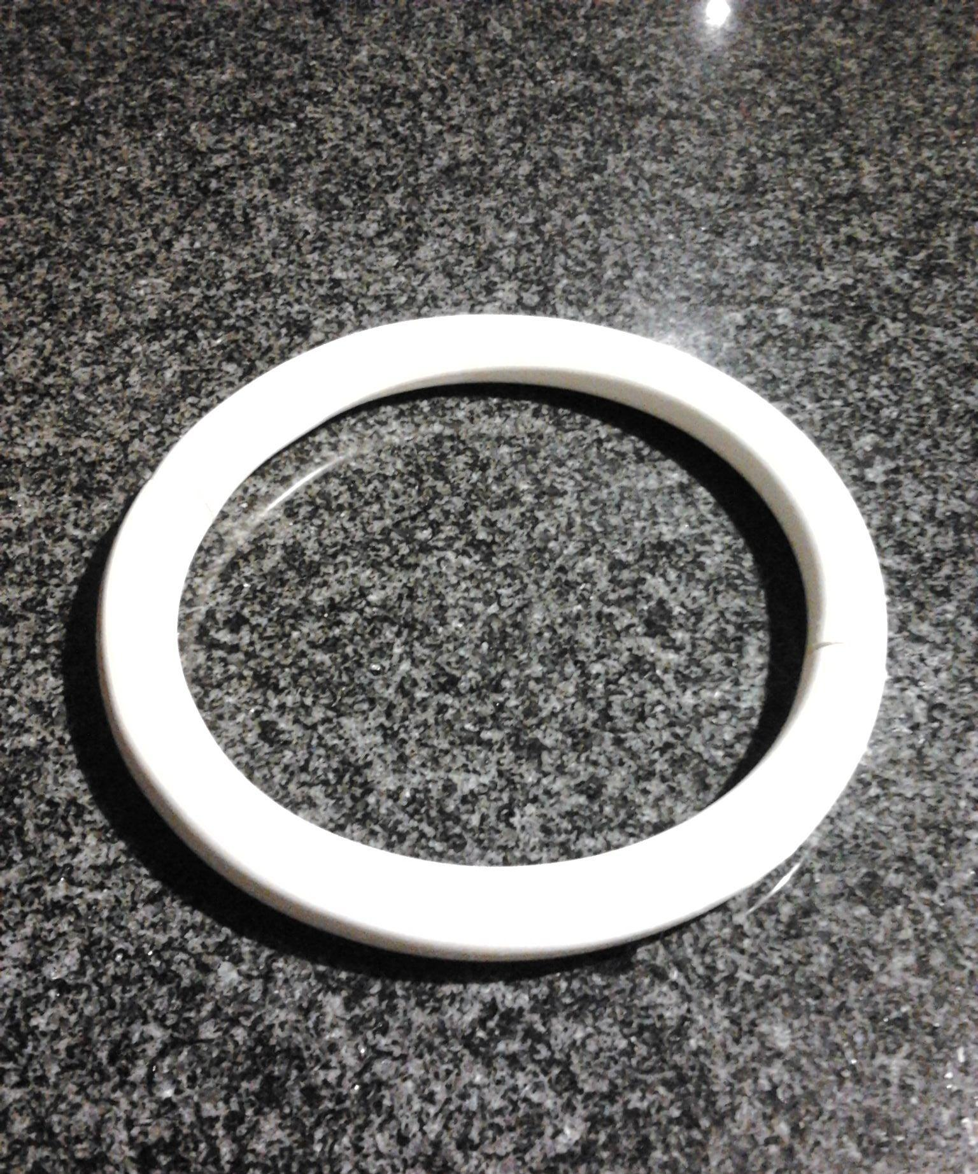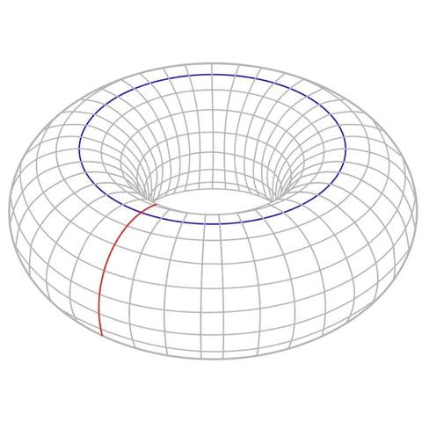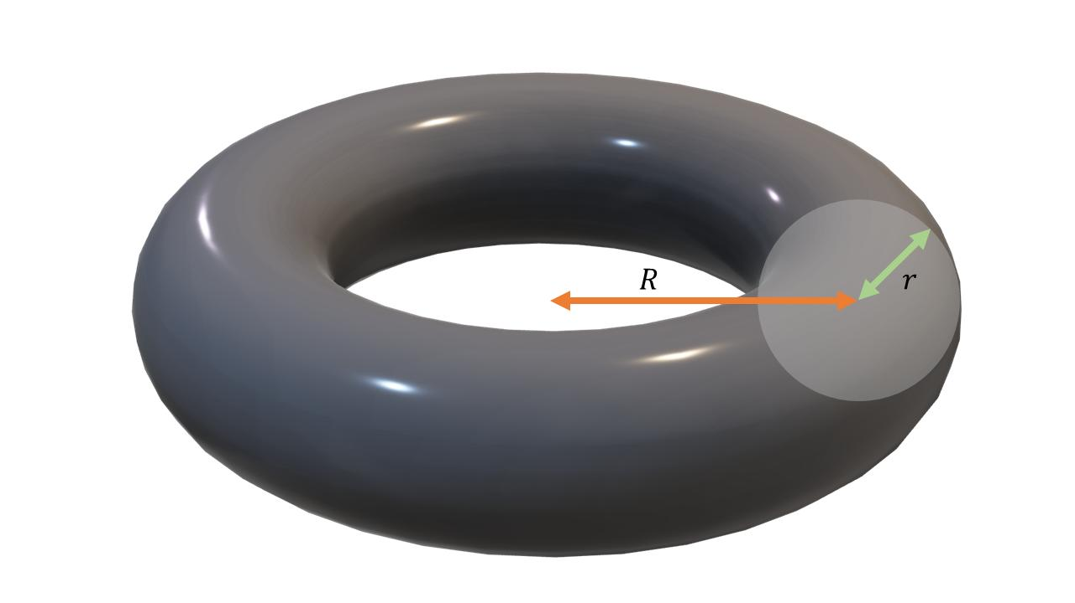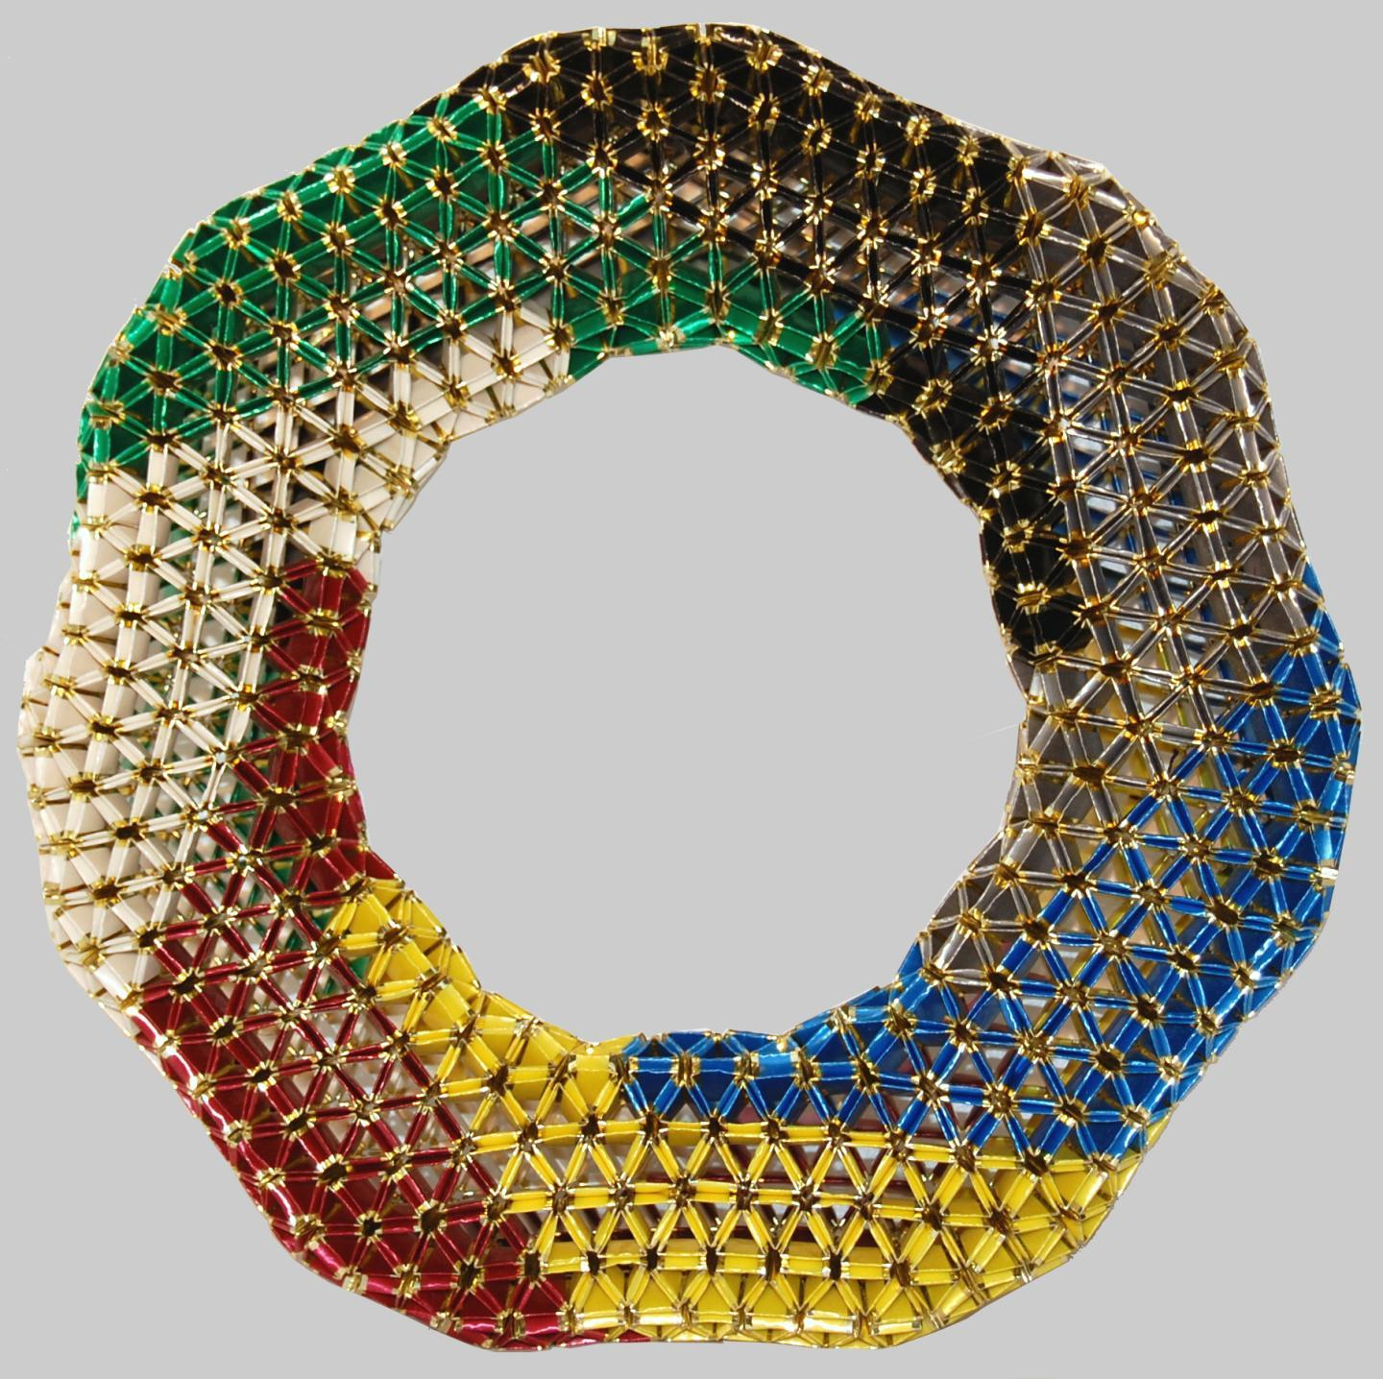
- Determine the required major radius $R$ and tube radius $r$.
- Select a flexible tube, hose, or suitable cylindrical material with the required thickness.
- Determine the required centerline circumference:
$$C=2πR$$
- Measure and cut the tube to the required centerline length, allowing for the joining connection.
- Prepare a circular bending template with radius $R$.
- Bend the tube gradually around the template.
- Bring the two ends together to form a complete circular ring.
- Join the ends using a suitable connector or adhesive.
- Adjust the ring to ensure that its centerline forms a circle.
- Check that the tube has a consistent diameter throughout.
- Smooth and secure the joint to complete the torus.

Method 4: Constructing a Torus Using a Wire-Frame Structure
# Source: AI Source: Provided by: [Data Path: Persons Table -> ID Column: 1, Name_En Column: Motasem Essam] -> From: [ChatGPT] on [7/25/2026]
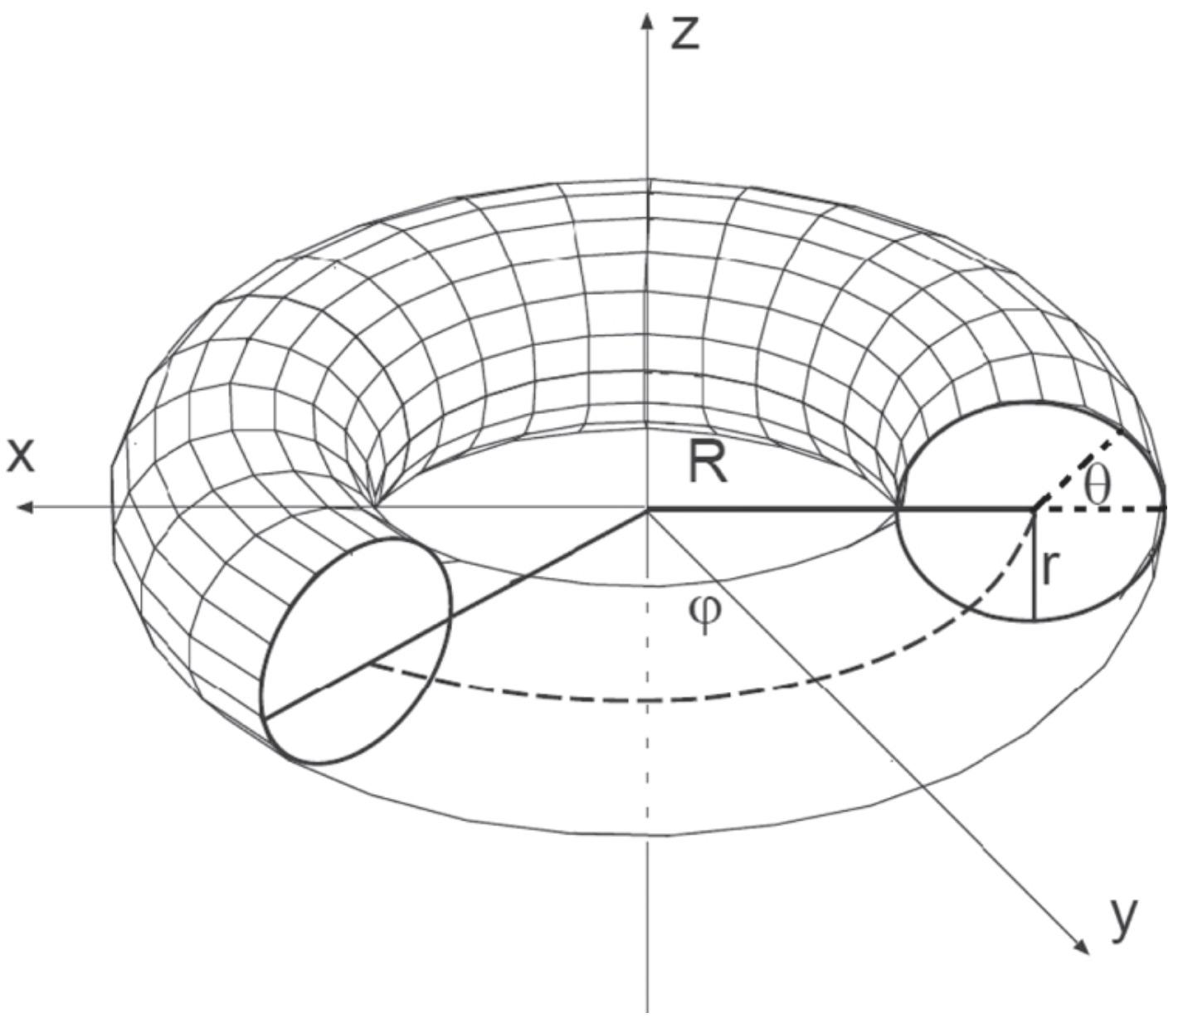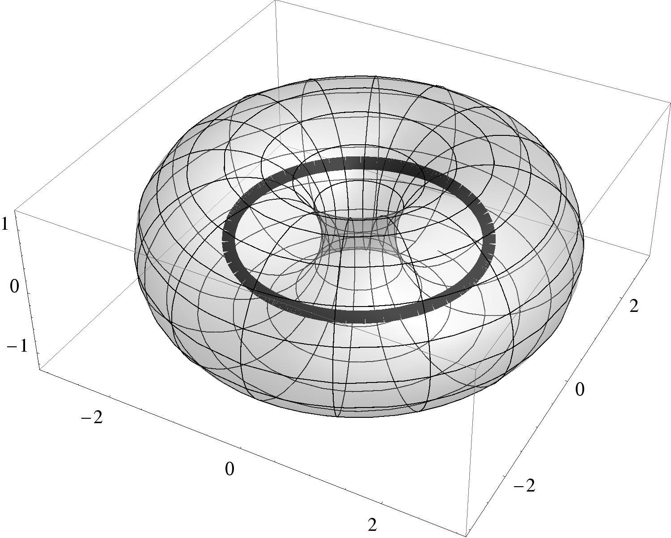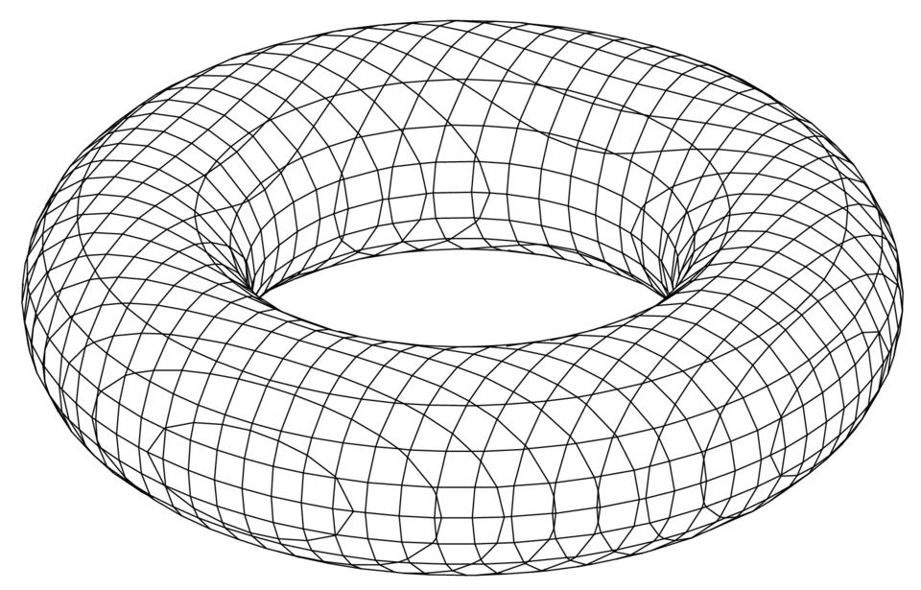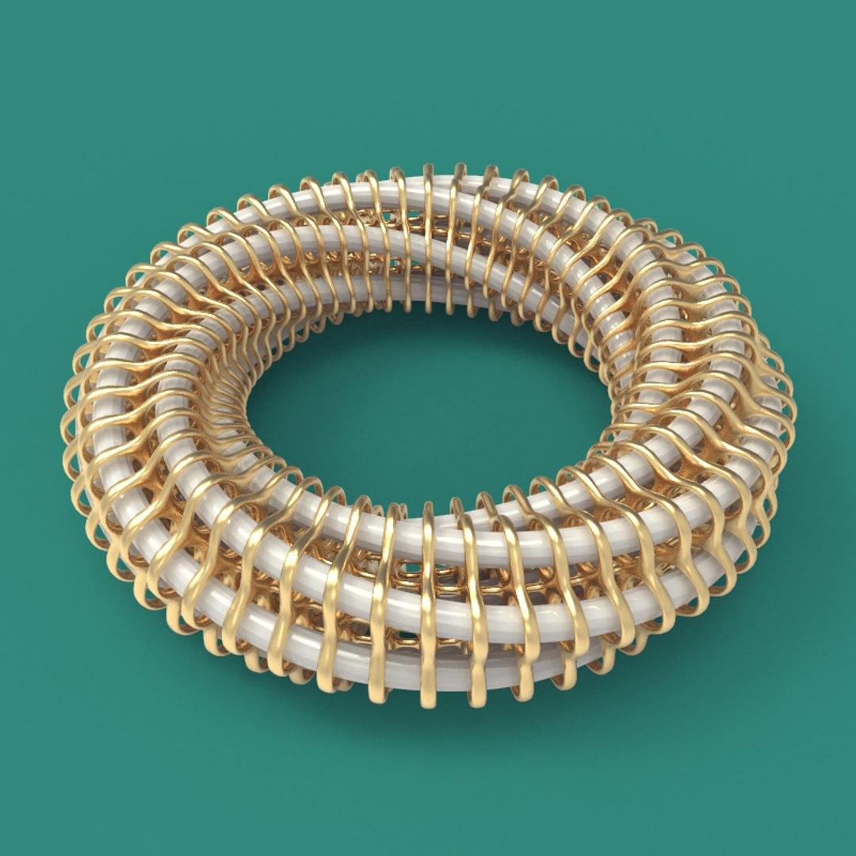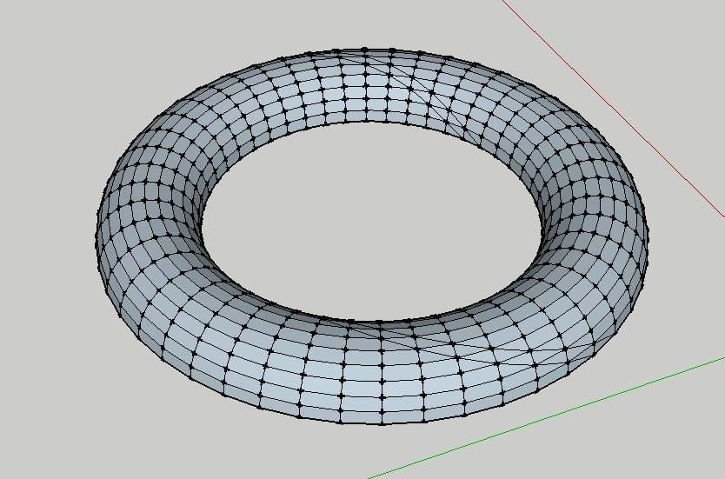
- Determine the required major radius $R$ and minor radius $r$.
- Draw a reference circle with radius $R$.
- Divide the circle into equal angular intervals.
- Mark the positions of the circular cross-sections around the reference circle.
- Bend flexible wire into a circular centerline with radius $R$.
- Construct circular wire sections with radius $r$.
- Attach the circular sections perpendicular to the centerline at the marked positions.
- Connect adjacent sections using curved wire ribs.
- Add additional supporting wires to maintain the circular tube shape.
- Check the uniformity of the tube and the central opening.
- Secure all intersections using suitable fasteners or adhesive.
- Cover the frame with flexible material if a solid surface is required.

Method 5: Constructing a Torus Using a Circular Mold
# Source: AI Source: Provided by: [Data Path: Persons Table -> ID Column: 1, Name_En Column: Motasem Essam] -> From: [ChatGPT] on [7/25/2026]
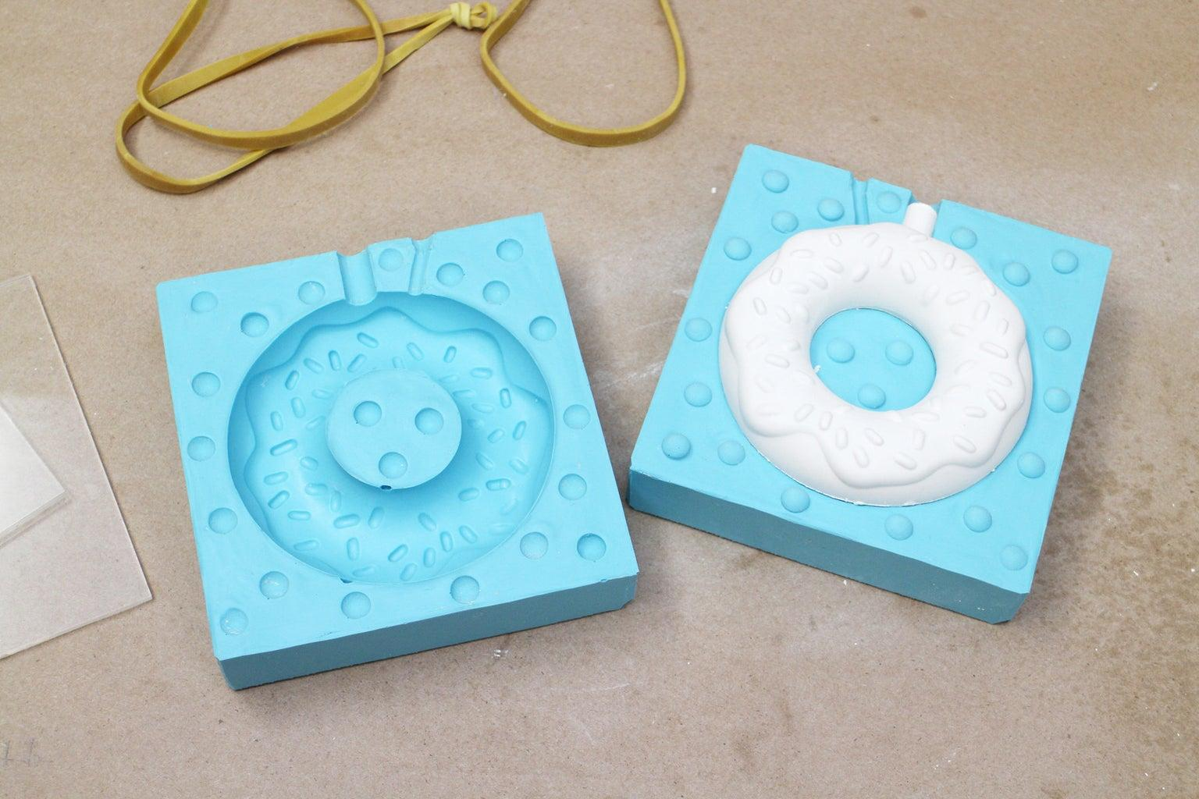
- Determine the required major radius $R$ and minor radius $r$.
- Prepare a toroidal mold with the intended ring-shaped cavity.
- Verify the major and minor dimensions using measuring instruments.
- Align the mold sections along their joining boundaries.
- Secure the mold sections together.
- Prepare a suitable modeling or casting material.
- Fill the mold evenly, ensuring that the material occupies the entire toroidal cavity.
- Allow the material to set or harden.
- Remove the mold sections, if the mold is designed to be removable.
- Smooth the joining boundaries and refine the toroidal surface.
- Measure the inner diameter, outer diameter, and tube diameter to verify the finished torus.

Method 6: Constructing a Torus Using a Circular Rotating Frame or Lathe
# Source: AI Source: Provided by: [Data Path: Persons Table -> ID Column: 1, Name_En Column: Motasem Essam] -> From: [ChatGPT] on [7/25/2026]
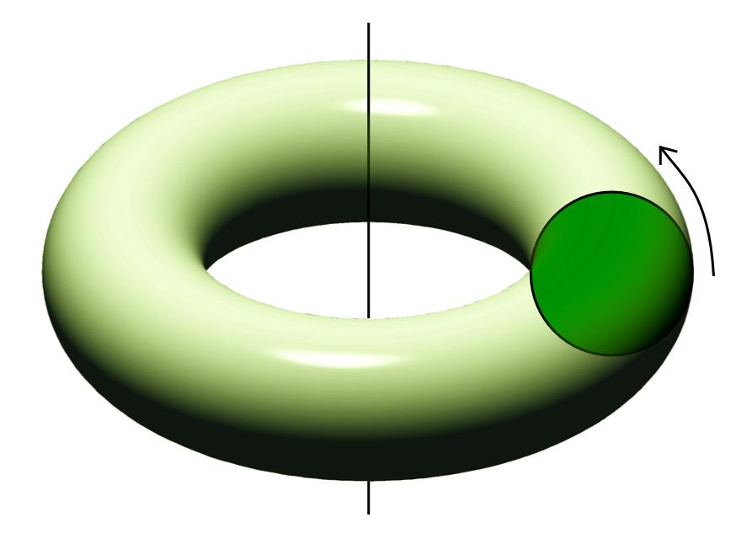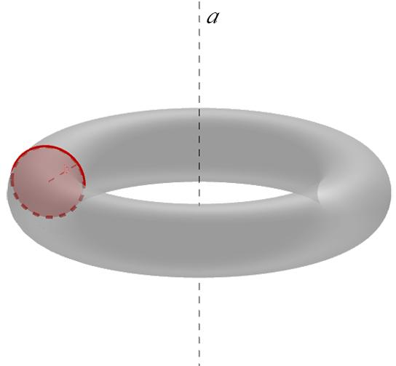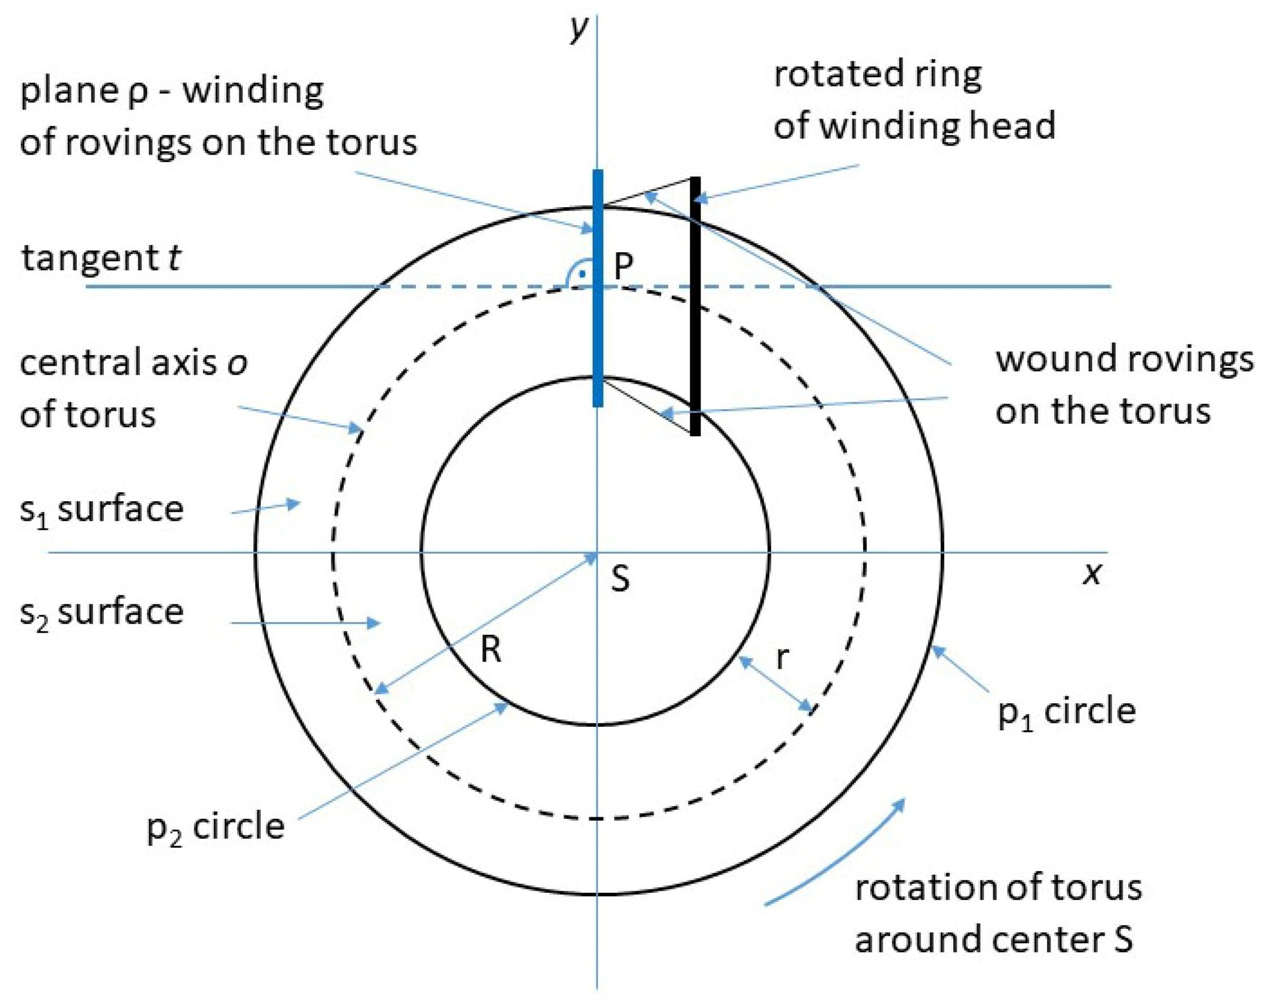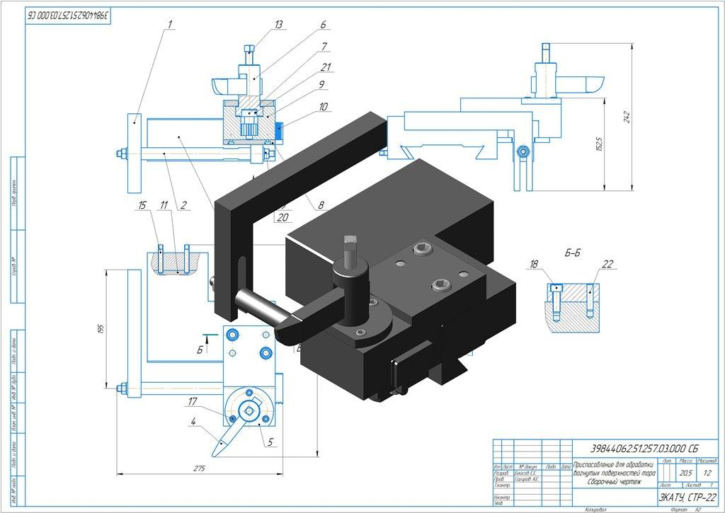
- Determine the required major radius $R$ and minor radius $r$.
- Draw the generating circle with radius $r$.
- Position its center at distance $R$ from the rotational axis.
- Prepare a rotating frame or shaping apparatus that maintains the generating circle's position.
- Secure the modeling material around the circular path of the generating profile.
- Align the rotational axis with the center of the intended torus.
- Rotate the apparatus through a complete ${360}^{°}$ revolution.
- Use the generating profile to shape the material into a continuous circular tube.
- Continue shaping until the tube has a uniform circular cross-section.
- Remove the finished torus from the apparatus.
- Smooth the surface and verify its dimensions.

Method 7: Constructing Horn and Spindle Tori
# Source: AI Source: Provided by: [Data Path: Persons Table -> ID Column: 1, Name_En Column: Motasem Essam] -> From: [ChatGPT] on [7/25/2026]
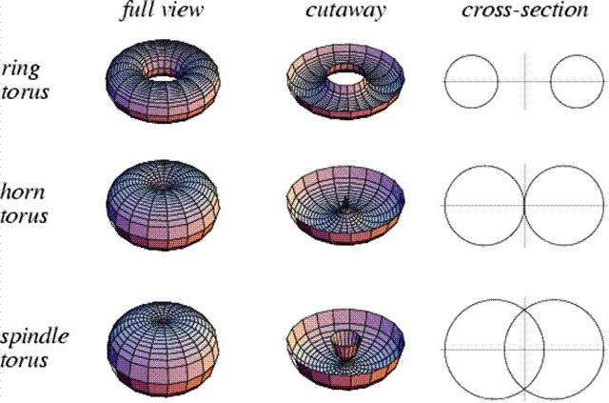
A. Horn Torus
- Select equal major and minor radii:
$$R=r$$
- Draw the rotational axis.
- Mark the center of the generating circle at distance $R$ from the axis.
- Draw the generating circle with radius $r$.
- Ensure that the circle is tangent to the rotational axis.
- Rotate the circle through ${360}^{°}$ around the axis.
- Shape the resulting surface, which closes at a single point on the axis.
B. Spindle Torus
- Select a major radius smaller than the minor radius:
$$R<r$$
- Draw the rotational axis.
- Mark the center of the generating circle at distance $R$ from the axis.
- Draw the generating circle with radius $r$.
- Ensure that the rotational axis intersects the generating circle.
- Rotate the circle through ${360}^{°}$ around the axis.
- Observe the resulting spindle-shaped, self-intersecting surface.
- Construct a physical model that distinguishes the intersecting portions of the surface.
The relationship between the two radii determines the torus type: $R>r$ produces a ring torus, $R=r$ produces a horn torus, and $R<r$ produces a spindle torus.

Mathematical Reference
# Source: AI Source: Provided by: [Data Path: Persons Table -> ID Column: 1, Name_En Column: Motasem Essam] -> From: [ChatGPT] on [7/25/2026]
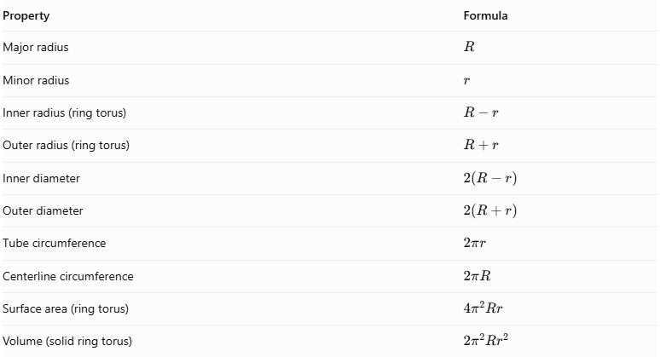
Property | Formula
Major radius | $$R$$
Minor radius | $$r$$
Inner radius (ring torus) | $$R-r$$
Outer radius (ring torus) | $$R+r$$
Inner diameter | $$2(R-r)$$
Outer diameter | $$2(R+r)$$
Tube circumference | $$2πr$$
Centerline circumference | $$2πR$$
Surface area (ring torus) | $$4π^{2}Rr$$
Volume (solid ring torus) | $$2π^{2}{Rr}^{2}$$
Construction note:
- Included: Instrument-Based Construction using compasses, rulers, protractors, circular templates, flexible rods, rotational frames, molds, and physical model assembly.
- Not Included: Coordinate-Based Construction using Cartesian coordinates, coordinate equations, or vertex-coordinate calculations.
- The standard ring torus is constructed when the major radius is greater than the minor radius.
- Horn and spindle tori require different relationships between the two radii.
- Circular-section and wire-frame methods produce approximations unless sufficiently refined.
Sources:
- Wolfram MathWorld – Torus — Torus geometry, radii, and classifications.
- MathCurve – Torus — Generation through rotation of a circle.
- NASA – Solid Modeling, Torus Construction — Construction using rotationally swept circular sections.
- Wolfram MathWorld – Spindle Torus — Spindle torus geometry.

Comparison with Related Solids
# Source: AI Source: Provided by: [Data Path: Persons Table -> ID Column: 1, Name_En Column: Motasem Essam] -> From: [ChatGPT] on [7/25/2026]
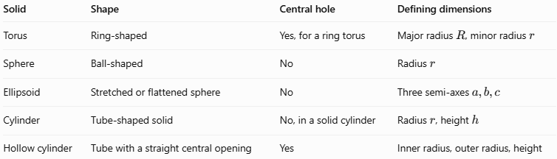
Solid | Shape | Central hole | Defining dimensions
Torus | Ring-shaped | Yes, for a ring torus | Major radius $R$, minor radius $r$
Sphere | Ball-shaped | No | Radius $r$
Ellipsoid | Stretched or flattened sphere | No | Three semi-axes $a,b,c$
Cylinder | Tube-shaped solid | No, in a solid cylinder | Radius $r$, height $h$
Hollow cylinder | Tube with a straight central opening | Yes | Inner radius, outer radius, height
A torus differs from a hollow cylinder because its tube curves around into a closed ring. It differs from a sphere because its ordinary ring form contains a hole.

Applications of Toruses
# Source: AI Source: Provided by: [Data Path: Persons Table -> ID Column: 1, Name_En Column: Motasem Essam] -> From: [ChatGPT] on [7/25/2026]
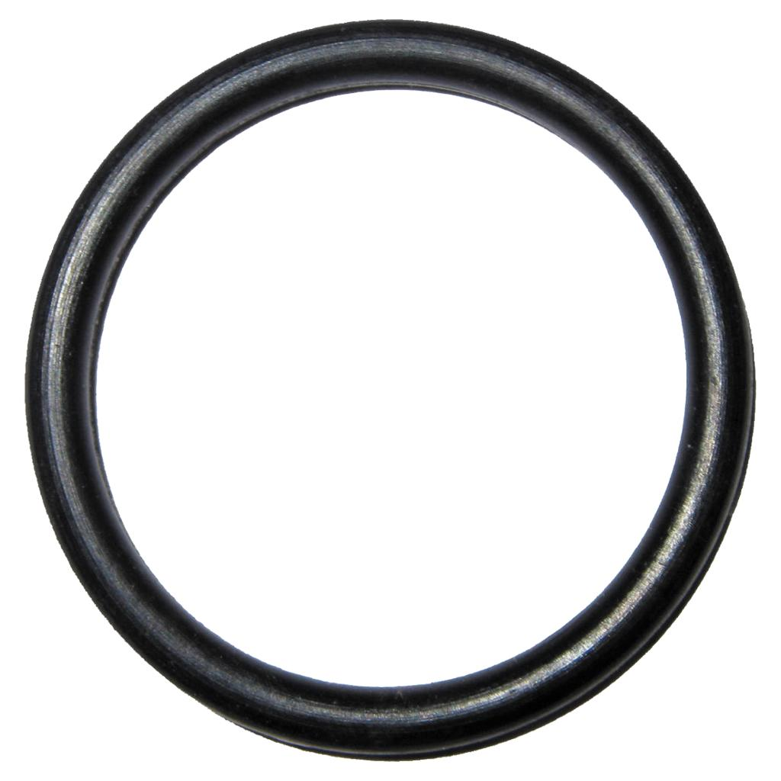
Mechanical engineering
Ring-shaped seals and O-rings have toroidal geometry and are used to help prevent leaks in mechanical systems.
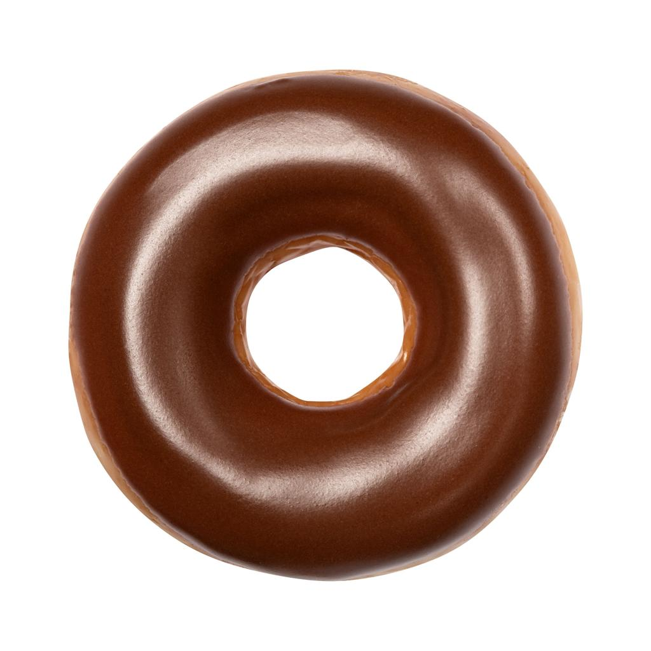
Food and product design
Doughnuts and other ring-shaped products provide familiar physical examples of toroidal shapes.
Electronics
Toroidal cores are used in inductors and transformers to guide magnetic flux through a ring-shaped core.
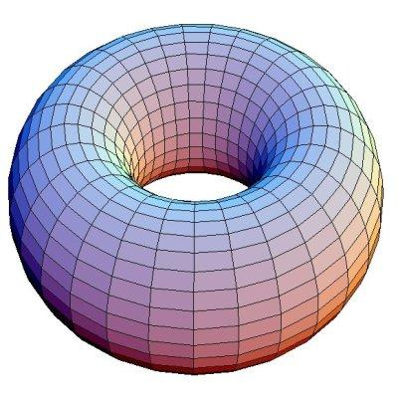
Mathematics and computer graphics
Toruses are used to study surfaces, parametric equations, rotational symmetry, and three-dimensional modeling.

Key Points
# Source: AI Source: Provided by: [Data Path: Persons Table -> ID Column: 1, Name_En Column: Motasem Essam] -> From: [ChatGPT] on [7/25/2026]
- A torus is a three-dimensional solid with a curved, ring-like shape.
- It is generated by rotating a circle around a coplanar axis.
- The major radius $R$ locates the center of the tube relative to the rotation axis.
- The minor radius $r$ measures the tube's radius.
- A ring torus has $R>r$; a horn torus has $R=r$; a spindle torus has $R<r$.
- The volume of a ring torus is $2π^{2}Rr^{2}$.
- The surface area of a ring torus is $4π^{2}Rr$.
- A standard ring torus has no flat faces, straight edges, or vertices.

Conclusion
# Source: AI Source: Provided by: [Data Path: Persons Table -> ID Column: 1, Name_En Column: Motasem Essam] -> From: [ChatGPT] on [7/25/2026]
A torus is an important solid in geometry characterized by its curved ring shape. Its major and minor radii determine its dimensions, volume, and surface area. The relationship between these radii also distinguishes the ring, horn, and spindle forms. Toruses have practical uses in engineering, electronics, product design, and mathematical modeling.

